**LAB#11**

**OBJECT: Implement the circuit of 2 bit parallel adder.**

**APPARATUS:**

* 74LS08
* 74LS86
* 74LS32
* Bread Board
* Connecting Wires
* LED
* DC Supply

**SYMBOLS:**

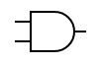

AND GATE

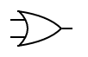

OR GATE

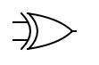

XOR GATE

**CIRCUIT DESIGN:**

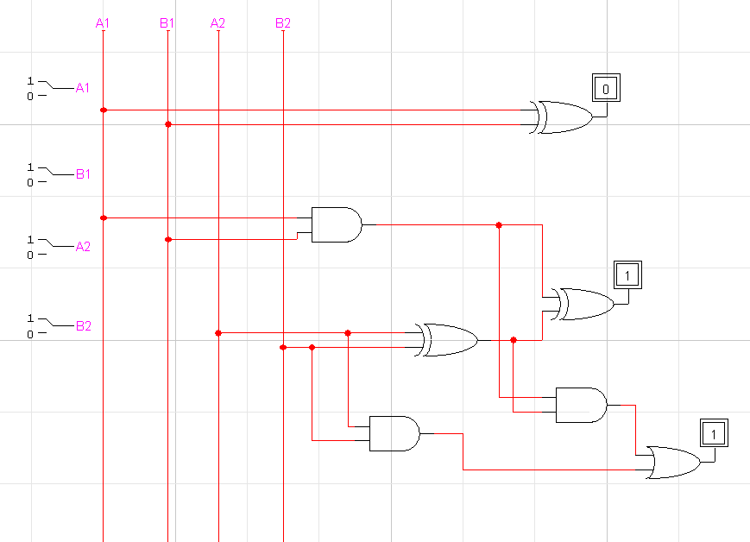

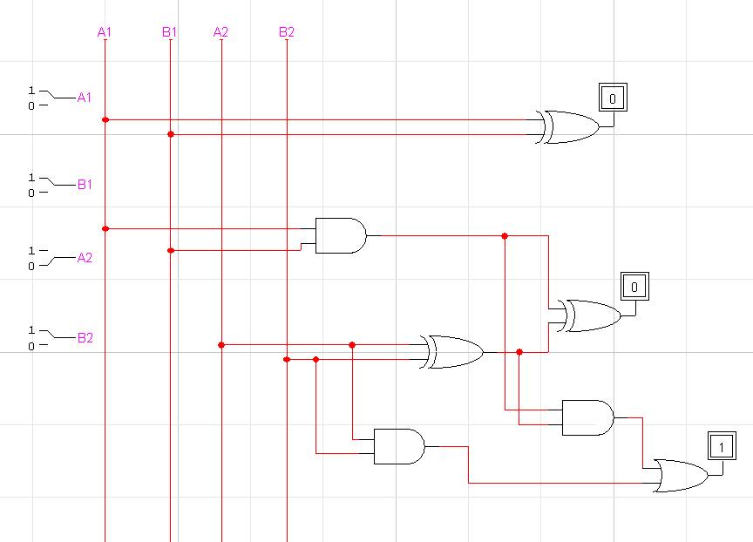

**CONCLUSION:**

The circuit is working according to the binary addition.